# What is Transmission media?

* Transmission media is a communication channel that carries the information from the sender to the receiver. Data is transmitted through the electromagnetic signals.
* The main functionality of the transmission media is to carry the information in the form of bits through **LAN**(Local Area Network).
* It is a physical path between transmitter and receiver in data communication.
* In a copper-based network, the bits in the form of electrical signals.
* In a fibre based network, the bits in the form of light pulses.
* In **OSI**(Open System Interconnection) phase, transmission media supports the Layer 1. Therefore, it is considered to be as a Layer 1 component.
* The electrical signals can be sent through the copper wire, fibre optics, atmosphere, water, and vacuum.
* The characteristics and quality of data transmission are determined by the characteristics of medium and signal.
* Transmission media is of two types are wired media and wireless media. In wired media, medium characteristics are more important whereas, in wireless media, signal characteristics are more important.
* Different transmission media have different properties such as bandwidth, delay, cost and ease of installation and maintenance.
* The transmission media is available in the lowest layer of the OSI reference model, i.e., **Physical layer**.

### **Some factors need to be considered for designing the transmission media:**

* **Bandwidth:** All the factors are remaining constant, the greater the bandwidth of a medium, the higher the data transmission rate of a signal.
* **Transmission impairment:** When the received signal is not identical to the transmitted one due to the transmission impairment. The quality of the signals will get destroyed due to transmission impairment.
* **Interference:** An interference is defined as the process of disrupting a signal when it travels over a communication medium on the addition of some unwanted signal.

## **Causes Of Transmission Impairment:**

* **Attenuation:** Attenuation means the loss of energy, i.e., the strength of the signal decreases with increasing the distance which causes the loss of energy.
* **Distortion:** Distortion occurs when there is a change in the shape of the signal. This type of distortion is examined from different signals having different frequencies. Each frequency component has its own propagation speed, so they reach at a different time which leads to the delay distortion.
* **Noise:** When data is travelled over a transmission medium, some unwanted signal is added to it which creates the noise.
* **Attenuation –** It means loss of energy. The strength of signal decreases with increasing distance which causes loss of energy in overcoming resistance of medium. This is also known as attenuated signal. Amplifiers are used to amplify the attenuated signal which gives the original signal back and compensate for this loss.

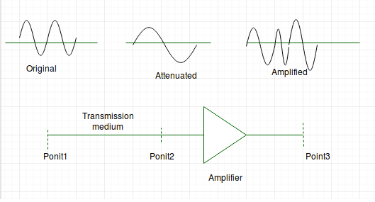

* Image Source – [aviationchief](http://www.aviationchief.com/uploads/9/2/0/9/92098238/19_1.jpg" \t "_blank)

Attenuation is measured in **decibels(dB)**. It measures the relative strengths of two signals or one signal at two different point. 

***Attenuation(dB) = 10log10(P2/P1)***

P1 is the power at sending end and P2 is the power at receiving  end.

Some where the decibel is also define in terms of voltage instead of power.In this case because power is proportional to the square of the voltage the formula is

***Attenuation(dB) = 20log10(V2/V1)***

V1 is the voltage at sending end and V2 is the voltage at receiving end.

* **Distortion –** It means changes in the form or shape of the signal. This is generally seen in composite signals made up with different frequencies. Each frequency component has its own propagation speed travelling through a medium. And thats why it delay in arriving at the final destination Every component arrive at different time which leads to distortion. Therefore, they have different phases at receiver end from what they had at senders end.

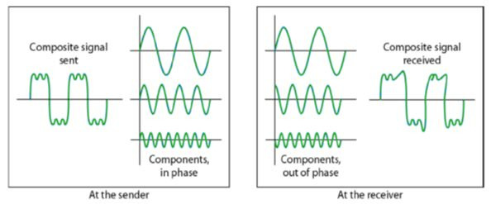

* **Noise –** The random or unwanted signal that mixes up with the original signal is called noise. There are several types of noise such as induced noise, crosstalk noise, thermal noise and impulse noise which may corrupt the signal.

**Induced** noise comes from sources such as motors and appliances. These devices act as sending antenna and transmission medium act as receiving antenna. **Thermal** noise is movement of electrons in wire which creates an extra signal. **Crosstalk** noise is when one wire affects the other wire. **Impulse** noise is a signal with high energy that comes from lightning or power lines 

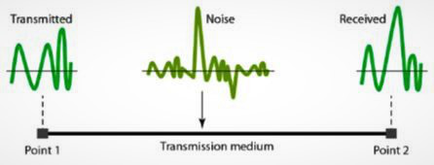

* To find the theoretical bit rate limit, we need to know the ration .The signal-to-noise ratio is defined as

**SNR = AVG SIGNAL POWER / AVG NOISE POWER**

# Guided Media

It is defined as the physical medium through which the signals are transmitted. It is also known as Bounded media.

Types Of Guided media:

## **Twisted pair:**

Twisted pair is a physical media made up of a pair of cables twisted with each other. A twisted pair cable is cheap as compared to other transmission media. Installation of the twisted pair cable is easy, and it is a lightweight cable. The frequency range for twisted pair cable is from 0 to 3.5KHz.

A twisted pair consists of two insulated copper wires arranged in a regular spiral pattern.

The degree of reduction in noise interference is determined by the number of turns per foot. Increasing the number of turns per foot decreases noise interference.

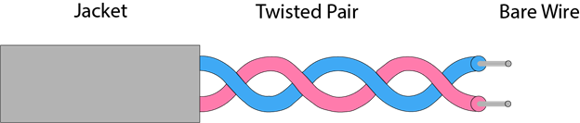

**Types of Twisted pair:**

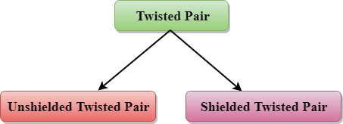

### **Unshielded Twisted Pair:**

An unshielded twisted pair is widely used in telecommunication. Following are the categories of the unshielded twisted pair cable:

* **Category 1:** Category 1 is used for telephone lines that have low-speed data.
* **Category 2:** It can support upto 4Mbps.
* **Category 3:** It can support upto 16Mbps.
* **Category 4:** It can support upto 20Mbps. Therefore, it can be used for long-distance communication.
* **Category 5:** It can support upto 200Mbps.

**Advantages Of Unshielded Twisted Pair:**

* It is cheap.
* Installation of the unshielded twisted pair is easy.
* It can be used for high-speed LAN.

**Disadvantage:**

* This cable can only be used for shorter distances because of attenuation.

### **Shielded Twisted Pair**

A shielded twisted pair is a cable that contains the mesh surrounding the wire that allows the higher transmission rate.

**Characteristics Of Shielded Twisted Pair:**

* The cost of the shielded twisted pair cable is not very high and not very low.
* An installation of STP is easy.
* It has higher capacity as compared to unshielded twisted pair cable.
* It has a higher attenuation.
* It is shielded that provides the higher data transmission rate.

**Disadvantages**

* It is more expensive as compared to UTP and coaxial cable.
* It has a higher attenuation rate.

## **Coaxial Cable**

* Coaxial cable is very commonly used transmission media, for example, TV wire is usually a coaxial cable.
* The name of the cable is coaxial as it contains two conductors parallel to each other.
* It has a higher frequency as compared to Twisted pair cable.
* The inner conductor of the coaxial cable is made up of copper, and the outer conductor is made up of copper mesh. The middle core is made up of non-conductive cover that separates the inner conductor from the outer conductor.
* The middle core is responsible for the data transferring whereas the copper mesh prevents from the **EMI**(Electromagnetic interference).

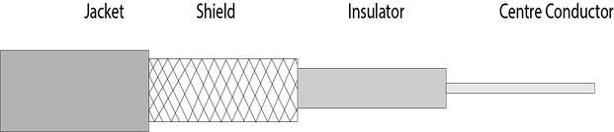

**Coaxial cable is of two types:**

1. **Baseband transmission:** It is defined as the process of transmitting a single signal at high speed.
2. **Broadband transmission:** It is defined as the process of transmitting multiple signals simultaneously.

**Advantages Of Coaxial cable:**

* The data can be transmitted at high speed.
* It has better shielding as compared to twisted pair cable.
* It provides higher bandwidth.

**Disadvantages Of Coaxial cable:**

* It is more expensive as compared to twisted pair cable.
* If any fault occurs in the cable causes the failure in the entire network.

## **Fibre Optic**

* Fibre optic cable is a cable that uses electrical signals for communication.
* Fibre optic is a cable that holds the optical fibres coated in plastic that are used to send the data by pulses of light.
* The plastic coating protects the optical fibres from heat, cold, electromagnetic interference from other types of wiring.
* Fibre optics provide faster data transmission than copper wires.

**Diagrammatic representation of fibre optic cable:**

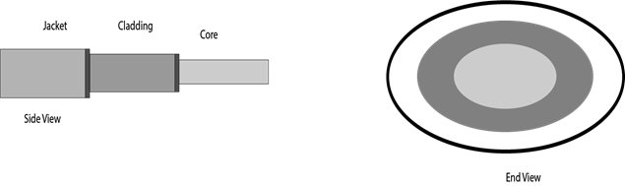

**Basic elements of Fibre optic cable:**

* **Core:** The optical fibre consists of a narrow strand of glass or plastic known as a core. A core is a light transmission area of the fibre. The more the area of the core, the more light will be transmitted into the fibre.
* **Cladding:** The concentric layer of glass is known as cladding. The main functionality of the cladding is to provide the lower refractive index at the core interface as to cause the reflection within the core so that the light waves are transmitted through the fibre.
* **Jacket:** The protective coating consisting of plastic is known as a jacket. The main purpose of a jacket is to preserve the fibre strength, absorb shock and extra fibre protection.

**Following are the advantages of fibre optic cable over copper:**

* **Greater Bandwidth:** The fibre optic cable provides more bandwidth as compared copper. Therefore, the fibre optic carries more data as compared to copper cable.
* **Faster speed:** Fibre optic cable carries the data in the form of light. This allows the fibre optic cable to carry the signals at a higher speed.
* **Longer distances:** The fibre optic cable carries the data at a longer distance as compared to copper cable.
* **Better reliability:** The fibre optic cable is more reliable than the copper cable as it is immune to any temperature changes while it can cause obstruct in the connectivity of copper cable.
* **Thinner and Sturdier:** Fibre optic cable is thinner and lighter in weight so it can withstand more pull pressure than copper cable.

# UnGuided Transmission

* An unguided transmission transmits the electromagnetic waves without using any physical medium. Therefore it is also known as **wireless transmission**.
* In unguided media, air is the media through which the electromagnetic energy can flow easily.

Unguided transmission is broadly classified into three categories:

## **Radio waves**

* Radio waves are the electromagnetic waves that are transmitted in all the directions of free space.
* Radio waves are omnidirectional, i.e., the signals are propagated in all the directions.
* The range in frequencies of radio waves is from 3Khz to 1 khz.
* In the case of radio waves, the sending and receiving antenna are not aligned, i.e., the wave sent by the sending antenna can be received by any receiving antenna.
* An example of the radio wave is **FM radio**.

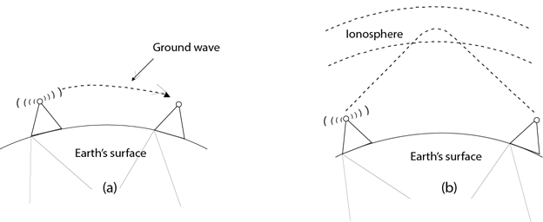

**Applications Of Radio waves:**

* A Radio wave is useful for multicasting when there is one sender and many receivers.
* An FM radio, television, cordless phones are examples of a radio wave.

**Advantages Of Radio transmission:**

* Radio transmission is mainly used for wide area networks and mobile cellular phones.
* Radio waves cover a large area, and they can penetrate the walls.
* Radio transmission provides a higher transmission rate.

## **Microwaves**

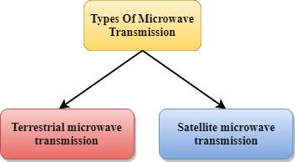

Microwaves are of two types:

* Terrestrial microwave
* Satellite microwave communication.

### **Terrestrial Microwave Transmission**

* Terrestrial Microwave transmission is a technology that transmits the focused beam of a radio signal from one ground-based microwave transmission antenna to another.
* Microwaves are the electromagnetic waves having the frequency in the range from 1GHz to 1000 GHz.
* Microwaves are unidirectional as the sending and receiving antenna is to be aligned, i.e., the waves sent by the sending antenna are narrowly focussed.
* In this case, antennas are mounted on the towers to send a beam to another antenna which is km away.
* It works on the line of sight transmission, i.e., the antennas mounted on the towers are the direct sight of each other.

**Characteristics of Microwave:**

* **Frequency range:** The frequency range of terrestrial microwave is from 4-6 GHz to 21-23 GHz.
* **Bandwidth:** It supports the bandwidth from 1 to 10 Mbps.
* **Short distance:** It is inexpensive for short distance.
* **Long distance:** It is expensive as it requires a higher tower for a longer distance.
* **Attenuation:** Attenuation means loss of signal. It is affected by environmental conditions and antenna size.

**Advantages Of Microwave:**

* Microwave transmission is cheaper than using cables.
* It is free from land acquisition as it does not require any land for the installation of cables.
* Microwave transmission provides an easy communication in terrains as the installation of cable in terrain is quite a difficult task.
* Communication over oceans can be achieved by using microwave transmission.

**Disadvantages of Microwave transmission:**

* **Eavesdropping:** An eavesdropping creates insecure communication. Any malicious user can catch the signal in the air by using its own antenna.
* **Out of phase signal:** A signal can be moved out of phase by using microwave transmission.
* **Susceptible to weather condition:** A microwave transmission is susceptible to weather condition. This means that any environmental change such as rain, wind can distort the signal.
* **Bandwidth limited:** Allocation of bandwidth is limited in the case of microwave transmission.

### **Satellite Microwave Communication**

* A satellite is a physical object that revolves around the earth at a known height.
* Satellite communication is more reliable nowadays as it offers more flexibility than cable and fibre optic systems.
* We can communicate with any point on the globe by using satellite communication.

**How Does Satellite work?**

The satellite accepts the signal that is transmitted from the earth station, and it amplifies the signal. The amplified signal is retransmitted to another earth station.

**Advantages Of Satellite Microwave Communication:**

* The coverage area of a satellite microwave is more than the terrestrial microwave.
* The transmission cost of the satellite is independent of the distance from the centre of the coverage area.
* Satellite communication is used in mobile and wireless communication applications.
* It is easy to install.
* It is used in a wide variety of applications such as weather forecasting, radio/TV signal broadcasting, mobile communication, etc.

**Disadvantages Of Satellite Microwave Communication:**

* Satellite designing and development requires more time and higher cost.
* The Satellite needs to be monitored and controlled on regular periods so that it remains in orbit.
* The life of the satellite is about 12-15 years. Due to this reason, another launch of the satellite has to be planned before it becomes non-functional.

## **Infrared**

* An infrared transmission is a wireless technology used for communication over short ranges.
* The frequency of the infrared in the range from 300 GHz to 400 THz.
* It is used for short-range communication such as data transfer between two cell phones, TV remote operation, data transfer between a computer and cell phone resides in the same closed area.

**Characteristics Of Infrared:**

* It supports high bandwidth, and hence the data rate will be very high.
* Infrared waves cannot penetrate the walls. Therefore, the infrared communication in one room cannot be interrupted by the nearby rooms.
* An infrared communication provides better security with minimum interference.
* Infrared communication is unreliable outside the building because the sun rays will interfere with the infrared waves.

# What is Multiplexing?

Multiplexing is a technique used to combine and send the multiple data streams over a single medium. The process of combining the data streams is known as multiplexing and hardware used for multiplexing is known as a multiplexer.

Multiplexing is achieved by using a device called Multiplexer (**MUX**) that combines n input lines to generate a single output line. Multiplexing follows many-to-one, i.e., n input lines and one output line.

Demultiplexing is achieved by using a device called Demultiplexer (**DEMUX**) available at the receiving end. DEMUX separates a signal into its component signals (one input and n outputs). Therefore, we can say that demultiplexing follows the one-to-many approach.

## **Why Multiplexing?**

* The transmission medium is used to send the signal from sender to receiver. The medium can only have one signal at a time.
* If there are multiple signals to share one medium, then the medium must be divided in such a way that each signal is given some portion of the available bandwidth. For example: If there are 10 signals and bandwidth of medium is100 units, then the 10 unit is shared by each signal.
* When multiple signals share the common medium, there is a possibility of collision. Multiplexing concept is used to avoid such collision.
* Transmission services are very expensive.

## **History of Multiplexing**

* Multiplexing technique is widely used in telecommunications in which several telephone calls are carried through a single wire.
* Multiplexing originated in telegraphy in the early 1870s and is now widely used in communication.
* George Owen Squier developed the **telephone carrier multiplexing** in 1910.

## **Concept of Multiplexing**

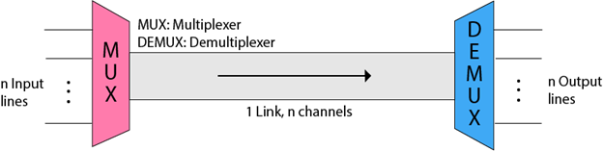

* The 'n' input lines are transmitted through a multiplexer and multiplexer combines the signals to form a composite signal.
* The composite signal is passed through a Demultiplexer and demultiplexer separates a signal to component signals and transfers them to their respective destinations.

## **Advantages of Multiplexing:**

* More than one signal can be sent over a single medium.
* The bandwidth of a medium can be utilized effectively.

## **Multiplexing Techniques**

Multiplexing techniques can be classified as:

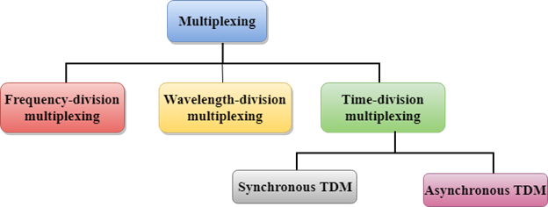

## **Frequency-division Multiplexing (FDM)**

* It is an analog technique.
* **Frequency Division Multiplexing** is a technique in which the available bandwidth of a single transmission medium is subdivided into several channels.

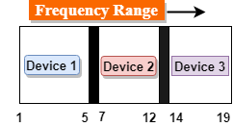

* In the above diagram, a single transmission medium is subdivided into several frequency channels, and each frequency channel is given to different devices. Device 1 has a frequency channel of range from 1 to 5.
* The input signals are translated into frequency bands by using modulation techniques, and they are combined by a multiplexer to form a composite signal.
* The main aim of the FDM is to subdivide the available bandwidth into different frequency channels and allocate them to different devices.
* Using the modulation technique, the input signals are transmitted into frequency bands and then combined to form a composite signal.
* The carriers which are used for modulating the signals are known as **sub-carriers**. They are represented as f1,f2..fn.
* **FDM** is mainly used in radio broadcasts and TV networks.

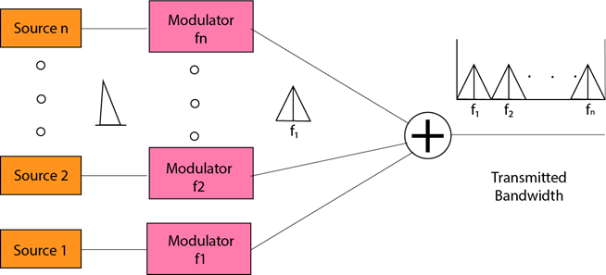

**Advantages Of FDM:**

* FDM is used for analog signals.
* FDM process is very simple and easy modulation.
* A Large number of signals can be sent through an FDM simultaneously.
* It does not require any synchronization between sender and receiver.

**Disadvantages Of FDM:**

* FDM technique is used only when low-speed channels are required.
* It suffers the problem of crosstalk.
* A Large number of modulators are required.
* It requires a high bandwidth channel.

**Applications Of FDM:**

* FDM is commonly used in TV networks.
* It is used in FM and AM broadcasting. Each FM radio station has different frequencies, and they are multiplexed to form a composite signal. The multiplexed signal is transmitted in the air.

## **Wavelength Division Multiplexing (WDM)**

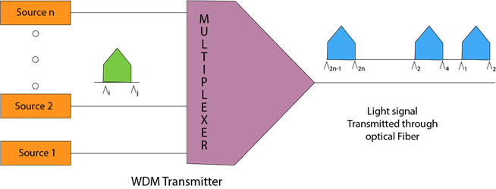

* Wavelength Division Multiplexing is same as FDM except that the optical signals are transmitted through the fibre optic cable.
* WDM is used on fibre optics to increase the capacity of a single fibre.
* It is used to utilize the high data rate capability of fibre optic cable.
* It is an analog multiplexing technique.
* Optical signals from different source are combined to form a wider band of light with the help of multiplexer.
* At the receiving end, demultiplexer separates the signals to transmit them to their respective destinations.
* Multiplexing and Demultiplexing can be achieved by using a prism.
* Prism can perform a role of multiplexer by combining the various optical signals to form a composite signal, and the composite signal is transmitted through a fibre optical cable.
* Prism also performs a reverse operation, i.e., demultiplexing the signal.

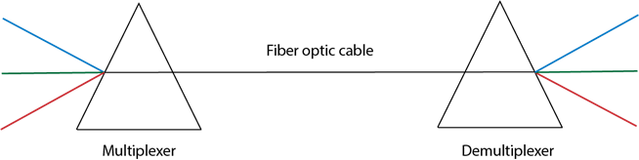

## **Time Division Multiplexing**

* It is a digital technique.
* In Frequency Division Multiplexing Technique, all signals operate at the same time with different frequency, but in case of Time Division Multiplexing technique, all signals operate at the same frequency with different time.
* In **Time Division Multiplexing technique**, the total time available in the channel is distributed among different users. Therefore, each user is allocated with different time interval known as a Time slot at which data is to be transmitted by the sender.
* A user takes control of the channel for a fixed amount of time.
* In Time Division Multiplexing technique, data is not transmitted simultaneously rather the data is transmitted one-by-one.
* In TDM, the signal is transmitted in the form of frames. Frames contain a cycle of time slots in which each frame contains one or more slots dedicated to each user.
* It can be used to multiplex both digital and analog signals but mainly used to multiplex digital signals.

**There are two types of TDM:**

* Synchronous TDM
* Asynchronous TDM

# Switching

* When a user accesses the internet or another computer network outside their immediate location, messages are sent through the network of transmission media. This technique of transferring the information from one computer network to another network is known as **switching**.
* Switching in a computer network is achieved by using switches. A switch is a small hardware device which is used to join multiple computers together with one local area network (LAN).
* Network switches operate at layer 2 (Data link layer) in the OSI model.
* Switching is transparent to the user and does not require any configuration in the home network.
* Switches are used to forward the packets based on MAC addresses.
* A Switch is used to transfer the data only to the device that has been addressed. It verifies the destination address to route the packet appropriately.
* It is operated in full duplex mode.
* Packet collision is minimum as it directly communicates between source and destination.
* It does not broadcast the message as it works with limited bandwidth.

## **Why is Switching Concept required?**

Switching concept is developed because of the following reasons:

* **Bandwidth:** It is defined as the maximum transfer rate of a cable. It is a very critical and expensive resource. Therefore, switching techniques are used for the effective utilization of the bandwidth of a network.
* **Collision:** Collision is the effect that occurs when more than one device transmits the message over the same physical media, and they collide with each other. To overcome this problem, switching technology is implemented so that packets do not collide with each other.

### **Advantages of Switching:**

* Switch increases the bandwidth of the network.
* It reduces the workload on individual PCs as it sends the information to only that device which has been addressed.
* It increases the overall performance of the network by reducing the traffic on the network.
* There will be less frame collision as switch creates the collision domain for each connection.

### **Disadvantages of Switching:**

* A Switch is more expensive than network bridges.
* A Switch cannot determine the network connectivity issues easily.
* Proper designing and configuration of the switch are required to handle multicast packets

# Switching techniques

In large networks, there can be multiple paths from sender to receiver. The switching technique will decide the best route for data transmission.

Switching technique is used to connect the systems for making one-to-one communication.

**Classification Of Switching Techniques**

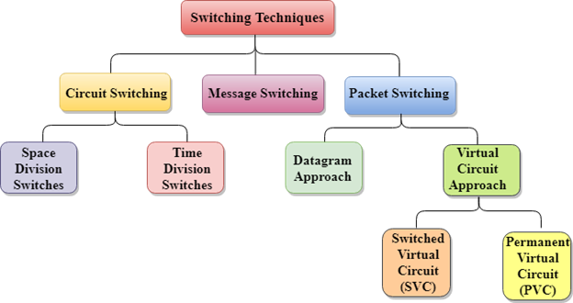

## **Circuit Switching**

* Circuit switching is a switching technique that establishes a dedicated path between sender and receiver.
* In the Circuit Switching Technique, once the connection is established then the dedicated path will remain to exist until the connection is terminated.
* Circuit switching in a network operates in a similar way as the telephone works.
* A complete end-to-end path must exist before the communication takes place.
* In case of circuit switching technique, when any user wants to send the data, voice, video, a request signal is sent to the receiver then the receiver sends back the acknowledgment to ensure the availability of the dedicated path. After receiving the acknowledgment, dedicated path transfers the data.
* Circuit switching is used in public telephone network. It is used for voice transmission.
* Fixed data can be transferred at a time in circuit switching technology.

**Communication through circuit switching has 3 phases:**

10 Sec

20M

440

How to find Nth Highest Salary in SQL

* Circuit establishment
* Data transfer
* Circuit Disconnect

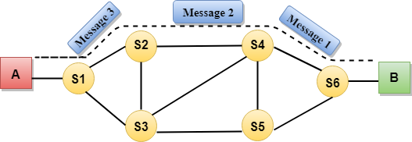

Circuit Switching can use either of the two technologies:

### **Space Division Switches:**

* Space Division Switching is a circuit switching technology in which a single transmission path is accomplished in a switch by using a physically separate set of crosspoints.
* Space Division Switching can be achieved by using crossbar switch. A crossbar switch is a metallic crosspoint or semiconductor gate that can be enabled or disabled by a control unit.
* The Crossbar switch is made by using the semiconductor. For example, Xilinx crossbar switch using FPGAs.
* Space Division Switching has high speed, high capacity, and nonblocking switches.

**Space Division Switches can be categorized in two ways:**

* **Crossbar Switch**
* **Multistage Switch**

### **Crossbar Switch**

The Crossbar switch is a switch that has n input lines and n output lines. The crossbar switch has n2 intersection points known as **crosspoints.**

**Disadvantage of Crossbar switch:**

The number of crosspoints increases as the number of stations is increased. Therefore, it becomes very expensive for a large switch. The solution to this is to use a multistage switch.

### **Multistage Switch**

* Multistage Switch is made by splitting the crossbar switch into the smaller units and then interconnecting them.
* It reduces the number of crosspoints.
* If one path fails, then there will be an availability of another path.

**Advantages Of Circuit Switching:**

* In the case of Circuit Switching technique, the communication channel is dedicated.
* It has fixed bandwidth.

**Disadvantages Of Circuit Switching:**

* Once the dedicated path is established, the only delay occurs in the speed of data transmission.
* It takes a long time to establish a connection approx 10 seconds during which no data can be transmitted.
* It is more expensive than other switching techniques as a dedicated path is required for each connection.
* It is inefficient to use because once the path is established and no data is transferred, then the capacity of the path is wasted.
* In this case, the connection is dedicated therefore no other data can be transferred even if the channel is free.

## **Message Switching**

* Message Switching is a switching technique in which a message is transferred as a complete unit and routed through intermediate nodes at which it is stored and forwarded.
* In Message Switching technique, there is no establishment of a dedicated path between the sender and receiver.
* The destination address is appended to the message. Message Switching provides a dynamic routing as the message is routed through the intermediate nodes based on the information available in the message.
* Message switches are programmed in such a way so that they can provide the most efficient routes.
* Each and every node stores the entire message and then forward it to the next node. This type of network is known as **store and forward network.**
* Message switching treats each message as an independent entity.

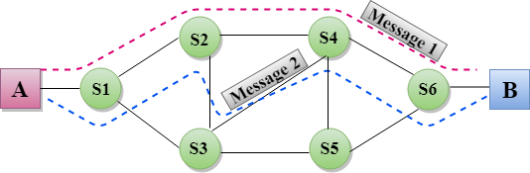

**Advantages Of Message Switching**

* Data channels are shared among the communicating devices that improve the efficiency of using available bandwidth.
* Traffic congestion can be reduced because the message is temporarily stored in the nodes.
* Message priority can be used to manage the network.
* The size of the message which is sent over the network can be varied. Therefore, it supports the data of unlimited size.

**Disadvantages Of Message Switching**

* The message switches must be equipped with sufficient storage to enable them to store the messages until the message is forwarded.
* The Long delay can occur due to the storing and forwarding facility provided by the message switching technique.

## **Packet Switching**

* The packet switching is a switching technique in which the message is sent in one go, but it is divided into smaller pieces, and they are sent individually.
* The message splits into smaller pieces known as packets and packets are given a unique number to identify their order at the receiving end.
* Every packet contains some information in its headers such as source address, destination address and sequence number.
* Packets will travel across the network, taking the shortest path as possible.
* All the packets are reassembled at the receiving end in correct order.
* If any packet is missing or corrupted, then the message will be sent to resend the message.
* If the correct order of the packets is reached, then the acknowledgment message will be sent.

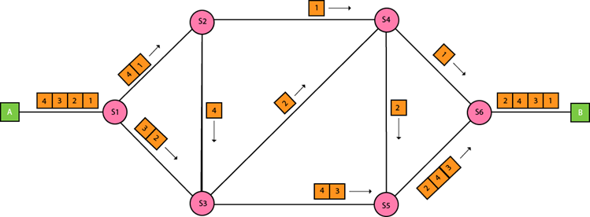

## **Approaches Of Packet Switching:**

There are two approaches to Packet Switching:

### **Datagram Packet switching:**

* It is a packet switching technology in which packet is known as a datagram, is considered as an independent entity. Each packet contains the information about the destination and switch uses this information to forward the packet to the correct destination.
* The packets are reassembled at the receiving end in correct order.
* In Datagram Packet Switching technique, the path is not fixed.
* Intermediate nodes take the routing decisions to forward the packets.
* Datagram Packet Switching is also known as connectionless switching.

### **Virtual Circuit Switching**

* Virtual Circuit Switching is also known as connection-oriented switching.
* In the case of Virtual circuit switching, a preplanned route is established before the messages are sent.
* Call request and call accept packets are used to establish the connection between sender and receiver.
* In this case, the path is fixed for the duration of a logical connection.